SCOPE OF WORK
Client Onboarding & Management Platform (PWA)
Client | ANT Analytics Pvt Ltd.
Website | https://antmeta.in/
Project | Custom CRM & Progressive Web App
Platform URL | traders.antmeta.ai (planned)
Document Version | 1.0
Date | February 2, 2026
Prepared By | DigiBull AI

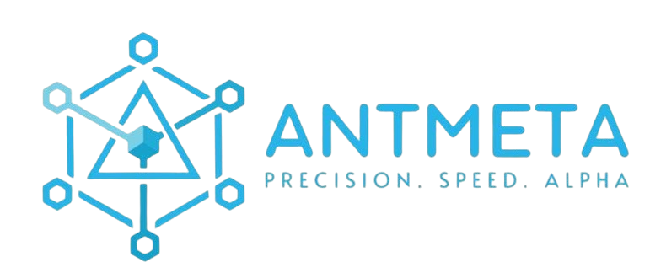


1. Project Overview
This document outlines the scope of work for building a custom CRM and Progressive Web App (PWA) for ANT Analytics Pvt Ltd. The platform will manage client onboarding, subscriptions, copy trading integration, P&L tracking, invoicing, and administrative operations.

1.1 Platform Type
- Progressive Web App (PWA) accessible via URL with install option on mobile devices
- Single codebase supporting future native app deployment without redevelopment
- Responsive design optimized for mobile-first usage
- Works across Android, iOS, and desktop browsers

1.2 Target Users
User Type | Description | Access Level
End Clients | Traders subscribing to copy trading services | Client PWA (self-service portal)
Super Admin | ANT internal team managing all operations | Full admin dashboard access
Partners | Affiliates managing their own client base | Restricted admin panel (limited sections)

2. Technology Stack
Layer | Technology
AI Development | Claude Code Opus 4.5 (BuLLM Vibe Coding System)
Frontend | React (PWA - Android & iOS compatible)
Backend & Database | Supabase (PostgreSQL, Auth, APIs, Storage)
Infrastructure | Cloud-based deployment (AWS or equivalent)
Security | Role-based access control, encrypted data handling, OTP authentication
Trading Integration | Delta Trading Platform API
Payment Gateway | Razorpay (India) + Stripe (International)
KYC Verification | DigiLocker / Aadhaar API (Automated)

3. Client PWA Features (10 Modules)
Self-service portal for end clients accessible at traders.antmeta.ai
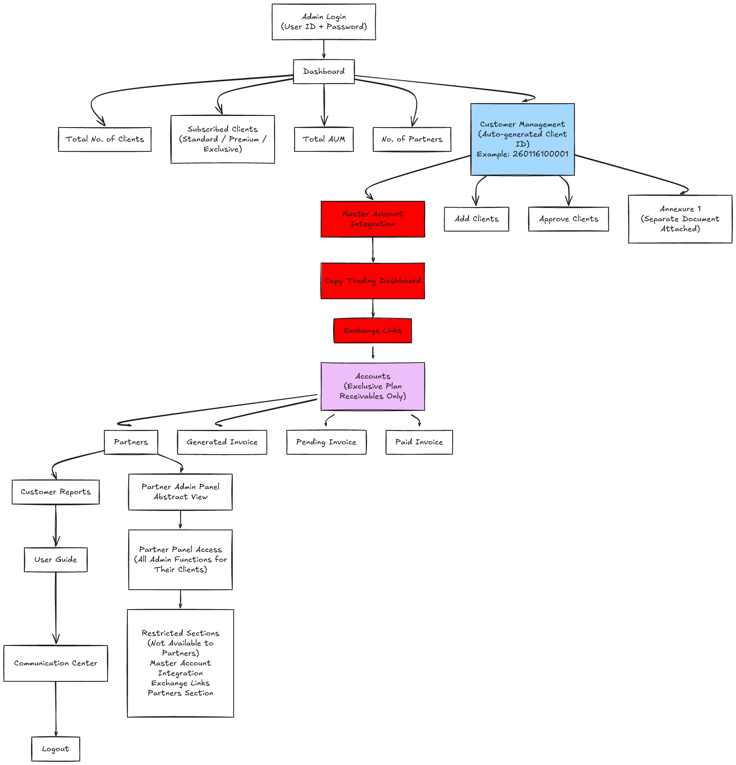

3.1 User Authentication
- Mobile number registration with OTP verification
- Forgot password flow with OTP reset
- Session management and secure logout

3.2 Profile Management
- Add/update profile picture
- Update email ID (with OTP verification to new email)
- Update mobile number (with OTP verification to new number)
- User ID display on dashboard
- Dark/Light theme toggle

3.3 KYC Document Upload
- PAN card upload and verification
- Aadhaar card upload and verification
- Automated verification via DigiLocker integration
- KYC status display (pending/verified/rejected)

3.4 Crypto Exchange Integration
- Exchange registration workflow
- API key management interface
- Integration with Delta trading platform
Note: API keys will remain securely managed within the trading platform. Delta API access and associated costs are the client's responsibility.

3.5 Subscription Management
- Three subscription tiers:
- Standard Plan: ₹10,000/month or ₹30,000/3 months
- Premium Plan: ₹15,000/month or ₹45,000/3 months
- Exclusive Plan: 25% on profits, billed every 90 days
- Plan upgrade/downgrade functionality
- Subscription status and renewal dates

3.6 Payment Gateway Integration
- Razorpay integration for Indian payments
- Stripe integration for international payments
- Payment history and receipts

3.7 P&L Analytics Dashboard
- Real-time P&L summaries pulled from Delta API
- Transaction history display
- Account analytics and performance metrics
- Visual charts and trend indicators
Technical Note: Backend requirements for real-time or daily data export to be documented. Data sync frequency TBD based on Delta API capabilities.

3.8 Invoice Management
- View pending invoices
- View paid invoices
- Download invoice PDFs
- Payment status tracking

3.9 Support Center
- Email support integration
- Chat support interface
- Telegram/WhatsApp redirect links
- User guide / Help documentation

3.10 Partner Application
- 'Become a Partner' application flow
- Partner application form
- Application status tracking

4. Admin Backend Features (6 Modules)
Administrative dashboard for ANT team with full operational control

4.1 Dashboard
- Total number of clients (all statuses)
- Subscribed clients breakdown (Standard / Premium / Exclusive)
- Total AUM (Assets Under Management)
- Number of active partners
- Key metrics and KPIs at a glance

4.2 Customer Management
- Auto-generated Client IDs (format: 260116100001)
- Add new clients manually
- Approve pending client registrations
- Client profile view and edit
- KYC document review and approval
- Client search and filtering
Annexure One: Additional customer management requirements to be provided by ANT.

4.3 Master Account & Copy Trading
- Master account integration for automated trade replication
- Copy trading dashboard to monitor all trading activity
- Exchange links management
- Client account connection status
- Trade replication logs
Dependency: ANT to share copy trading platform documentation and access with development team.

4.4 Accounts & Invoicing
- Accounts receivables (Exclusive plan clients only)
- P&L capture for profit-sharing calculations
- Automated invoice generation with flexible profit-sharing rules
- Invoice status tracking (Generated / Pending / Paid)
- Manual invoice creation option

4.5 Partner Management
- Partner list and directory
- Partner admin panel provisioning
- Restricted access configuration:
- Partners CANNOT access: Master Account Integration, Exchange Links, Partners Section
- Partners CAN access: All other admin functions for their own clients
- Partner performance reports
- Customer reports by partner

4.6 Communication Center
- Centralized client communication hub
- Message history and logs
- Broadcast messaging capability
- User guide management
- Logout functionality

5. Integration Requirements

5.1 Delta Trading Platform
Requirement | Details
API Access | Delta API credentials and documentation required from ANT
Data Points | P&L summaries, transaction history, account analytics, trade data
Sync Frequency | Real-time or daily (TBD based on API capabilities)
Master Account | Integration for automated trade replication to client accounts
Cost Responsibility | Delta API access and associated costs are ANT's responsibility

5.2 Payment Gateways
Gateway | Purpose
Razorpay | Indian client payments (INR transactions)
Stripe | International client payments (multi-currency)

API credentials to be provided by ANT for both gateways.

5.3 KYC Verification
- DigiLocker / Aadhaar API integration for automated verification
- PAN verification API
- Sandbox/test credentials required for development
- Production credentials required for go-live

6. UI/UX Requirements

6.1 Design Approach
- Mobile-first responsive design
- Optimized for both client and admin views
- Primary and secondary color selection following accessibility contrast standards
- Dark/Light theme support

6.2 Design Workflow
- ANT to finalize color scheme
- DigiBull to share UI samples with proposed color options
- Client review and feedback
- Final UI development post color scheme approval

6.3 Key Screens
- Client PWA: Registration, Dashboard, Profile, KYC, Subscription, P&L, Invoices, Support
- Admin Backend: Dashboard, Customer Management, Copy Trading, Invoicing, Partners, Communication

7. Timeline & Milestones
Phase | Duration | Deliverables
Phase 1: Setup | Day 1-2 | Environment setup, database schema, authentication framework
Phase 2: UI Samples | Day 3-5 | UI samples with color options, client review, color scheme finalization
Phase 3: Client PWA | Day 6-10 | All 10 client-facing modules developed and integrated
Phase 4: Admin Backend | Day 11-13 | All 6 admin modules developed and integrated
Phase 5: Integration | Day 14-15 | Delta API integration, payment gateways, KYC, final polish
Development Complete | 15 Days | Handoff for testing
Phase 6: UI Testing | 1 Week | Internal UI/UX testing, bug fixes, refinements
Phase 7: UAT | 2 Weeks | User Acceptance Testing with ANT team, feedback incorporation
Go-Live Ready | ~5 Weeks Total | Production deployment

8. Deliverables

8.1 Application Deliverables
- Fully functional Client PWA (10 modules)
- Fully functional Admin Backend (6 modules)
- Responsive design for mobile and desktop
- PWA installable on Android and iOS devices

8.2 Technical Deliverables
- Database schema and migrations
- API documentation
- Deployment configuration
- Environment setup guide

8.3 Documentation
- User guide for clients
- Admin manual for ANT team
- Technical handover documentation

9. Dependencies & Action Items

9.1 Required from ANT (Client)
# | Action Item | Status
1 | Finalize color scheme before UI development | Pending
2 | Share copy trading platform documentation and access | Pending
3 | Provide Annexure One with additional requirements | Pending
4 | Confirm hosting provider / migration to antmeta.ai domain | Pending
5 | Provide Delta API credentials and documentation | Pending
6 | Provide Razorpay API credentials | Pending
7 | Provide Stripe API credentials | Pending
8 | Provide DigiLocker/KYC API credentials (sandbox + production) | Pending

9.2 DigiBull Action Items
# | Action Item | Status
1 | Share UI samples with proposed primary and secondary color options | In Progress
2 | Document backend requirements for real-time/daily data export | Pending
3 | Setup development environment | Pending

10. Testing Plan

10.1 UI Testing (1 Week)
- Cross-browser compatibility testing
- Mobile responsiveness testing (Android, iOS)
- PWA installation testing
- Theme switching (dark/light) testing
- Form validation and error handling
- Performance and load time optimization

10.2 User Acceptance Testing - UAT (2 Weeks)
- End-to-end client journey testing
- Admin workflow testing
- Integration testing (Delta API, payments, KYC)
- Security and access control testing
- Data accuracy verification
- Feedback collection and bug resolution

11. Assumptions & Constraints

11.1 Assumptions
- All API credentials and documentation will be provided by ANT before development begins
- Color scheme will be finalized before UI development starts
- ANT team will be available for timely feedback during UAT
- Delta API supports required data points and sync frequency
- Copy trading platform documentation is available and complete

11.2 Constraints
- Delta API limitations may affect real-time data availability
- Third-party API rate limits may apply
- KYC verification dependent on DigiLocker API availability
- Timeline assumes no major scope changes during development

11.3 Out of Scope
- Native mobile app development (PWA only in this phase)
- Delta API subscription costs
- Third-party API subscription costs
- Custom reporting beyond defined requirements
- Ongoing content updates post-launch

— End of Scope of Work Document —
DigiBull AI | BuLLM Coding System | Claude Code Opus 4.5

